KIDNEY
ACTIONS

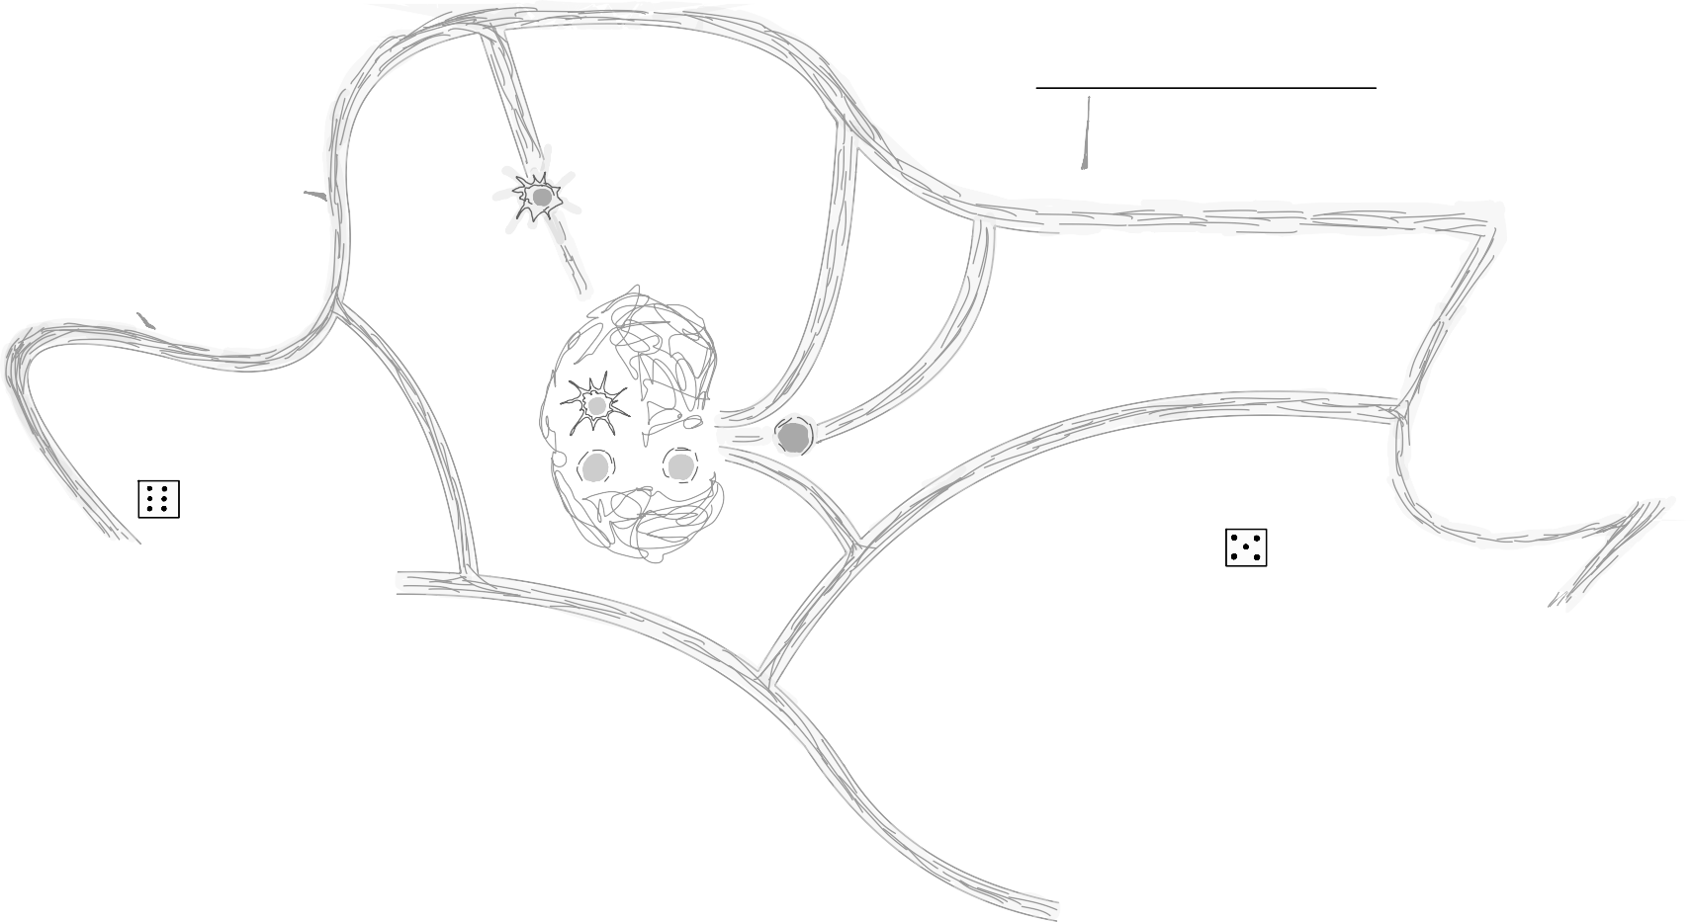
LYMPH-

NODE LYMPHATIC VESSELS
- ATP Movement dendritic cell
- ATP Movement other cells

HEART
LUNG
SKIN
Pathogen heart

COLON
Pathogen heart

T-CELL-ACTIVATION

LIVER

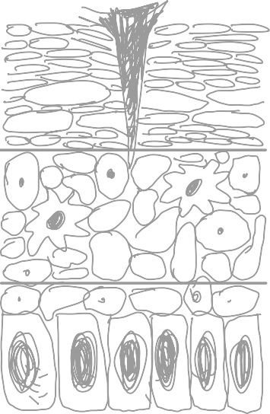
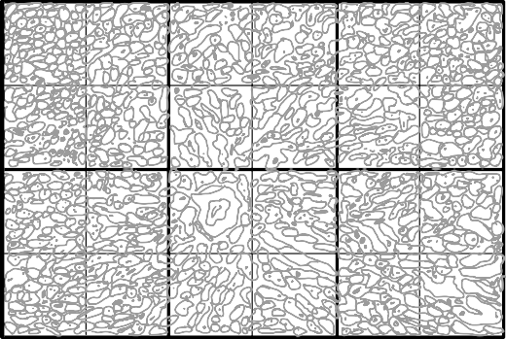

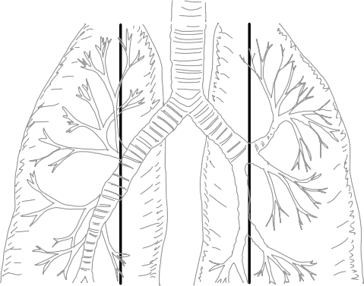

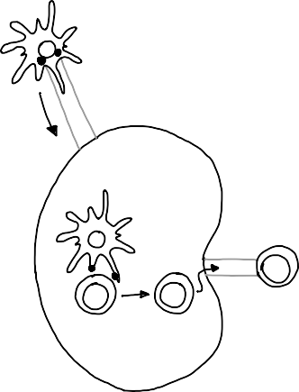


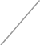
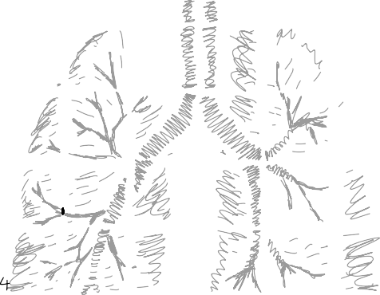


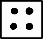

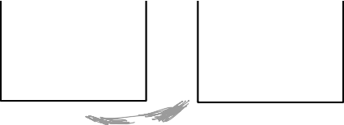


Pathogen colon
Pathogen Kidney
Pathogen Kidney
1 ATP Move a field
2 ATP Move past an antigen
2 ATP Switch immune cell
Pathogen
skin
Pathogen
lung
Pathogen
skin
Pathogen
lung
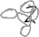

Pathogen colon

Pathogen liver

Pathogen liver
ACTIONS
1 ATP Move a field
2 ATP Move past an antigen
2 ATP Switch immune cell

