Goal of the Game
Inflammation! is a cooperative board game for 1–6 players. Players take on the roles of different immune cells to fight pathogens and build immunity.
Game Board
The board depicts several organs, each composed of 24 spaces. Organs are connected to each other and to the lymph node by lymphatic pathways. Every square is a playable space; the lymph node itself is also a space.
The lymphatic system is an important cleansing and defense network of the body that is primarily used by immune cells. It functions as a vessel-and-organ network similar to blood circulation but is specialized for immune-cell transport and tissue surveillance.

Setup
Shuffle the pathogen deck. Shuffle the combined virus and bacteria deck.
Assign organ pathogens. Starting with the kidney, draw two pathogen cards for each organ; those pathogens are the ones that can appear in that tissue.
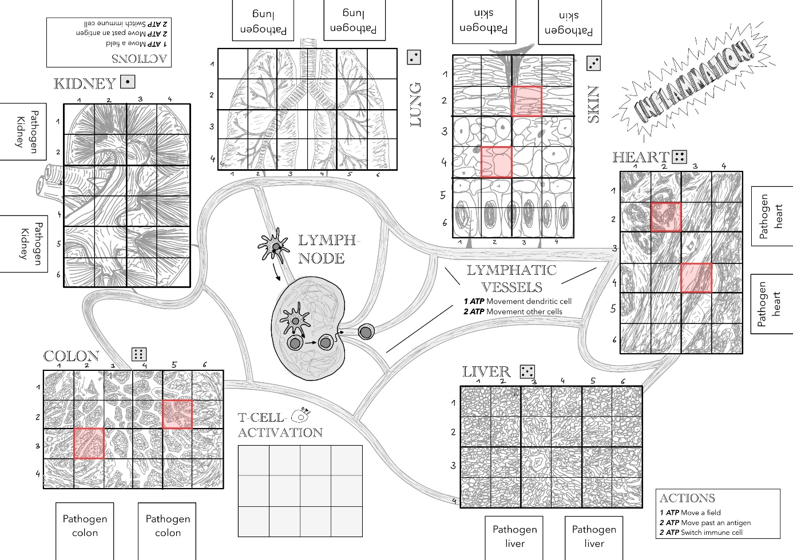
Place fixed initial infections. Six fixed starting positions are indicated in the reference image; place the matching antigen marker (by number) for each pathogen present at those positions. These markers represent infected cells.

Place three additional infections by dice. Roll coordinates either by rolling one die three times or by rolling three dice at once: first roll = organ, second = row, third = column. If a roll yields a coordinate that does not exist (for example a 5 or 6 where that space is invalid), reroll. If the chosen space is already occupied, reroll all dice. On the resulting free space place one of the two antigen markers according to the pathogen placement rules in the pathogen phase.
Choose cell markers. Each player chooses one or more cell markers that indicate positions on the board. If a player uses multiple markers they must set a fixed order; each marker takes its own turn. At least three cell markers must be in play. A marker may represent any cell type and may change cell type later. At game start each player may choose a tissue space at an exit of the lymph pathways and may freely choose one cell type without cost.
Prepare B-cell activation cards. Shuffle the B-cell activation cards and place them face down beside the board; their positions must remain unknown.

Turn Structure
Players take turns in clockwise order. On a player’s turn they must:
- Spend action points (ATP).
- Check the body status (win/lose conditions).
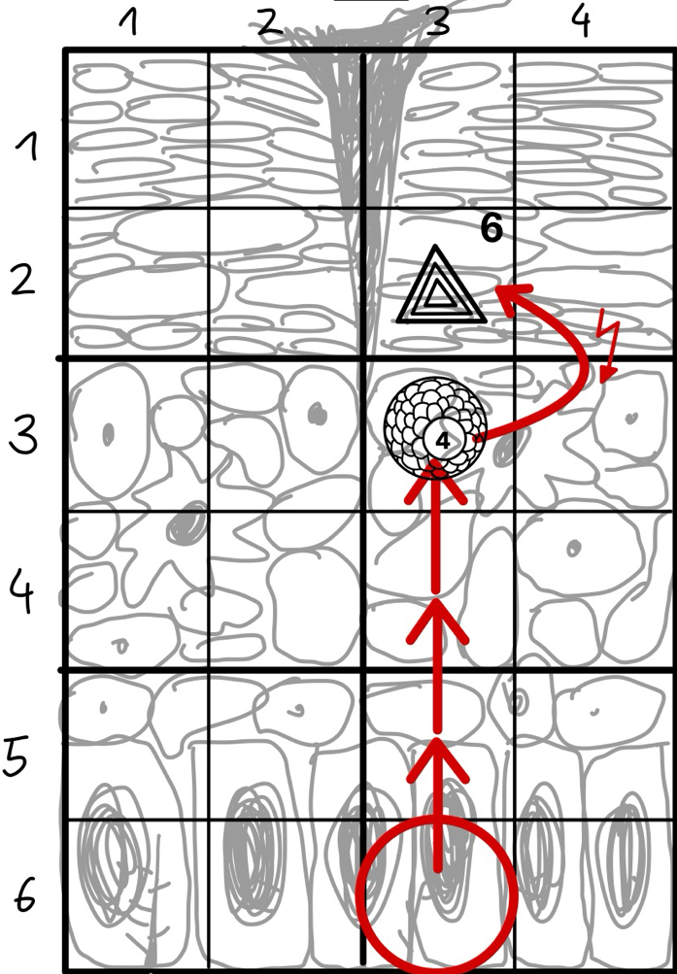
- Resolve the pathogen actions (viruses and bacteria).
Example:
A player acting as a macrophage moves three spaces forward (1 ATP per space) and spends 2 ATP to eat Virus 6. As a macrophage, they places that antigen on an free antigen slot on their cell card. As they save their last ATP, they take an ATP Marker.

Action Points (ATP)
- Each turn a player has 6 ATP.
- ATP (adenosine triphosphate) is the energy currency used to perform actions. Actions cost ATP; up to 3 ATP may be saved for later rounds.
Adenosine triphosphate (ATP) is the primary energy carrier inside living cells. Cells use ATP to power movement, biochemical reactions, and the active processes required for immune responses; ATP is consumed whenever a cell performs energy-dependent tasks.
There are general actions available to any cell and cell-specific actions that depend on the active cell type.

General Actions (available to any cell)
Move to an adjacent space (1 ATP per space):
Cell marker is placed on an adjacent field (orthogonal moves only; no diagonal). Multiple cell markers may occupy the same space.
Move onto an infected space (2 ATP per space):
Cell marker is placed on an adjacent field, also occupied by an pathogen.
Move to other tissue via lymph system (2 ATP):
In order to perform this action, the marker must be on a lymph connection or the lymph node; destination must be free of pathogens. The marker is then placed on any field with an lymph connection or in the lymph node.
Move to other tissue onto infected space (3 ATP):
One extra ATP because the destination is infected.
Change cell type (2 ATP):
The active cell-type kann be switched to any other (unless the card text explicitly forbids switching). To do so, swap the corresponding cell card next to the game plan.

Cell-Specific Actions
Place the active cell’s card beside the player; each card contains a short description of that cell’s actions.
Macrophages
Macrophages are large phagocytic cells that patrol tissues, engulf cells infected by bacteria or viruses and debris, and present antigenic material to other immune cells. They act as both first responders and as bridges to adaptive immunity by collecting and displaying pathogen fragments.
Phagocytic cells that can eat bacteria and virus-infected cells. They collect antigen markers on their cell card. While antigens are on a macrophage’s card, it may only switch to a dendritic cell (still costs 2 ATP).
Limit: At most half of the players/markers may be macrophages (round up).
- Eat cell/bacterium (2 ATP):
Move an adjacent antigen marker onto the macrophage’s card (neutralizes it). Only allowed if this would leave no more than 3 antigens on the macrophage card.
- Eat immune complex (3 ATP):
Only possible if B-cells have weakened pathogens with antibodies; all antigen markers weakened by an adjacent antibody can be eaten at once. If the macrophage card had no antigens before this action, it may temporarily hold more than 3 antigens. The antibody is removed after this action.
- Digest and regenerate (1 ATP):
Remove one antigen from field on the macrophage card so it can accept more.
- Pass antigens (1 ATP):
Pass any number of antigens to an adjacent dendritic cell (the dendritic cell must be on one of the four orthogonally adjacent spaces).
Dendritic Cells
Dendritic cells sample antigens in tissues and transport processed antigen information to lymphoid organs. There they present antigen to lymphocytes, initiating and shaping the adaptive immune response by activating specific T cells.
Sample antigens in tissues and carry antigen information to the lymph node to activate adaptive immune cells. While antigens are on a dendritic cell’s card, it may only switch to a macrophage (still 2 ATP).
- Sample antigen: 1 ATP — copy an adjacent antigen onto the dendritic cell card (the board antigen remains). Max 3 antigens carried.
- Receive antigens: 1 ATP — accept any number of antigens from an adjacent macrophage. Max 3 antigens carried.
- Movement via lymph: Movement over the lymph system costs 1 ATP less for dendritic cells.
- Activate T cells: 3 ATP — only in the lymph node; place all carried antigens onto the T-cell activation stack. The corresponding T cells become active for the rest of the game. If those antigens are already on the stack, they may instead be placed beside the board.
T Cells
T cells are part of the adaptive immune system and are found in the lymph node. They can recognize a specific antigen, but that antigen must be presented to them by dendritic cells for them to become activated. There are two major types of T cells.
Cytotoxic T cells (T-killer cells) migrate into organs after activation. They can send a “kill signal” to infected host cells, causing those cells to self-destruct and thereby preventing further spread of the virus.
Helper T cells support other immune cells in their activity. Among other functions, they can activate B cells in the lymph node.
A T cell specific to a pathogen can only be chosen as an active cell if the corresponding antigen marker is on the T-cell activation stack. More information can be found under Activating T cells. On the T-cell card an antigen marker must be placed to indicate which pathogen the cell is targeted against.
All actions of T-killer cells may be used only against virus (not bacteria!) antigen markers for which they have been specifically trained.
Activation requirement: A T cell can only be chosen if its antigen is on the T-cell activation stack; place an antigen marker on the T-cell card to indicate its target.
- Kill signal (1 ATP):
Send a death signal to an adjacent infected cell; remove the virus antigen marker from the board.
- Kill chain (2 ATP, once per turn):
After a kill, send another signal to an adjacent infected cell; remove that virus antigen marker and you may also remove one directly adjacent antigen marker of the same virus.
- Find and activate B cell (1 ATP):
In the lymph node, flip one B-cell activation card; if its antigen matches the T-helper’s antigen it stays revealed and can be chosen as a cell card; otherwise it is flipped back face down.
- Switch antigen: (1 ATP):
Change the active T cell to another T cell with a different target antigen.
B Cells
B cells are part of the adaptive immune system and are found in the lymph node. They can recognize a specific antigen, but that antigen must be presented to them for them to become activated. Once activated, they secrete antibodies. Antibodies act like a glue for matching pathogens, causing those pathogens to be weakened and making them easier to be phagocytosed.
B cells must be activated separately for each individual pathogen. A B cell specific to a pathogen can only be chosen as an active cell if the corresponding B-cell activation card is revealed. More information is available under Finding and activating B cells. On the B-cell card an antigen marker must be placed to indicate which pathogen the cell is targeted against.
- Secrete antibodies (3ATP):
Choose any 2×2 area that touches at least one space adjacent to the B cell (one of the 8 surrounding spaces). Place an antibody marker covering that 2×2 area and place the B cell’s antigen marker in the center of the antibody marker. All matching antigen markers in that 2×2 area become weakened, making them easier for macrophages to eat and harder for pathogens to spread.
- Switch antigen (1ATP):
Change the active B cell to another B cell with a different target antigen.
Neutrophils
Neutrophil granulocytes, the most numerous white blood cells, form the first line of defense of the innate immune system. They detect and engulf pathogens, providing a rapid, non-specific immune response.
Switching to a neutrophil granulocyte costs no ATP. A marker that is a neutrophil granulocyte cannot be changed to another cell. The player using this cell must skip their next turn. After that skipped turn they may place any cell on the marker without paying ATP.
- Neutralize pathogen: 1 ATP — remove an adjacent antigen marker.

Check Body Status
Loss condition: If 20 spaces in a single organ, or 13 or more spaces in two different organs, are occupied by antigen markers, the players lose.
Win condition: If all B-cell activation cards have been revealed, the immune response is considered strong enough and the players win.

Pathogen Phase (Viruses and Bacteria)
Spread roll: Roll coordinates either by rolling one die three times or by rolling three dice at once: first roll = organ, second = row, third = column. If a rolled coordinate is invalid, reroll. The effect depends on existing antigen markers at and around the target space.
Cases:
- Target space already has an antigen marker
  - Virus: add another antigen marker of that virus to the same space; if three markers stack, a virus explosion may occur (see below).
  - Bacterium: place that bacterium’s antigen markers on the four orthogonally adjacent spaces if they are free.
- Target space is free but up to 8 surrounding spaces contain antigen markers
  - Place the antigen of the pathogen that appears most frequently among the surrounding markers. If tied, place the antigen with the lower number.
- Target space and surrounding spaces are all free
  - Place the antigen of the pathogen that currently has fewer markers in that organ. If tied or none present, place the antigen with the lower number.
Virus Explosion
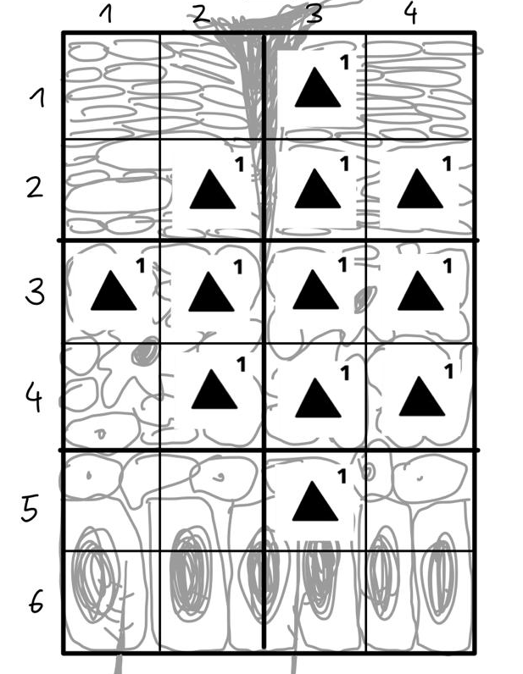
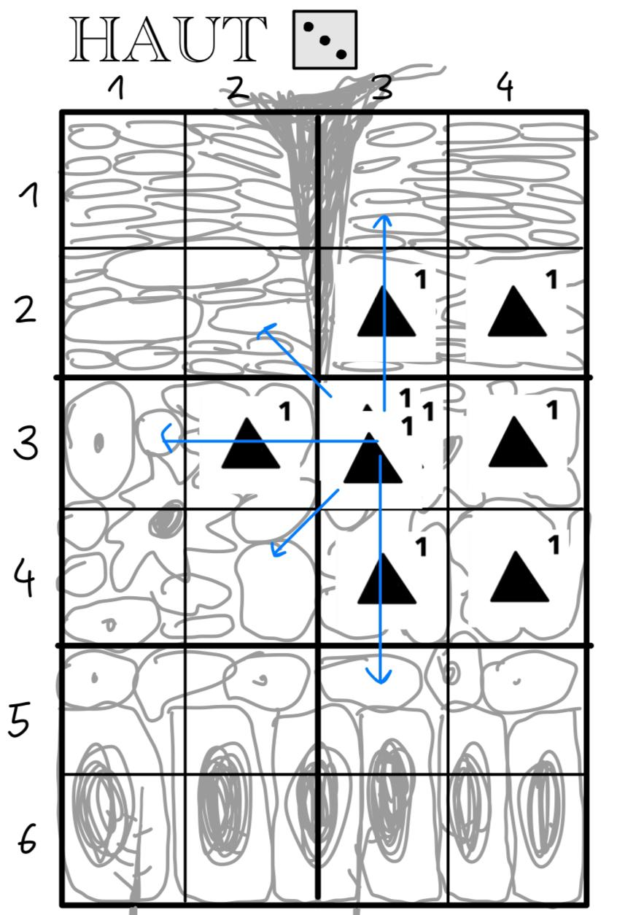
- When 3 virus antigen markers are stacked on one space a virus explosion occurs: all viruses from that “factory” are released and up to 8 adjacent free spaces are filled with that virus’s antigen marker. If one of the four orthogonally adjacent spaces is occupied, follow that direction outward until you find a free space or the organ edge; place the antigen on the first free space found.
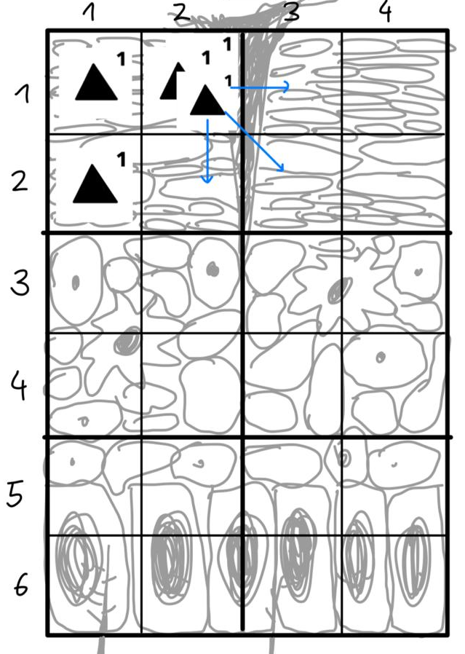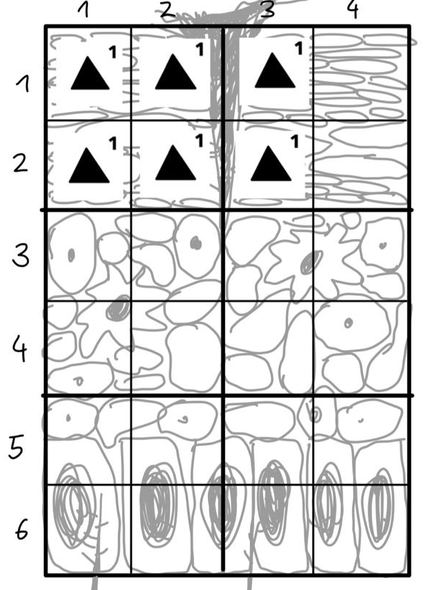
Antibodies and Their Effects
- Antibodies produced by B cells clump matching pathogen-bearing cells and weaken them.
- If a rolled space contains a pathogen that is weakened by an antibody, nothing happens.
- If a free space is rolled and among the up to 8 surrounding spaces there are antigen markers that are weakened by antibodies, the effect depends on whether all surrounding antigen markers are weakened:
  - If all are weakened, nothing happens.
  - If not all are weakened, treat the roll as in Case 2 above but ignore the weakened antigen markers when determining which antigen is most frequent.

Flowcharts
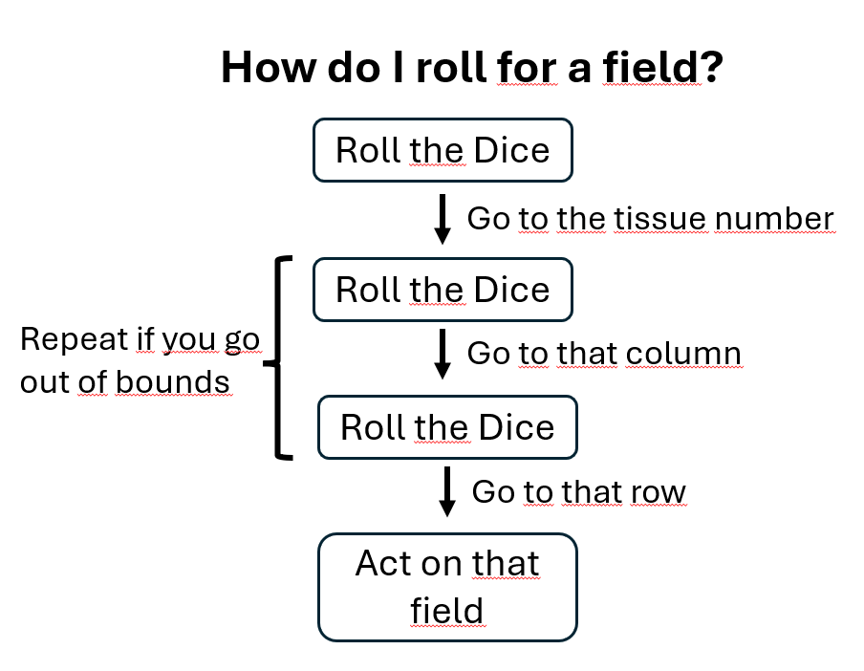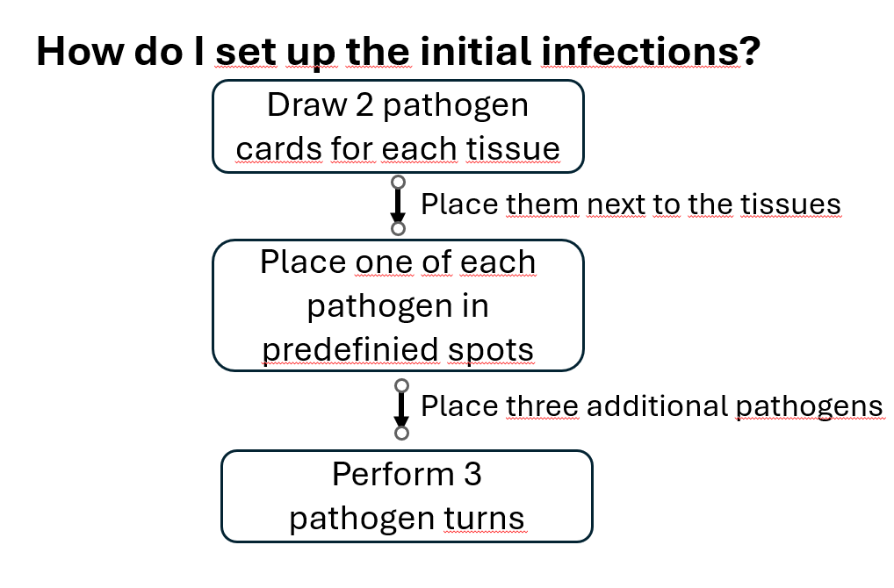
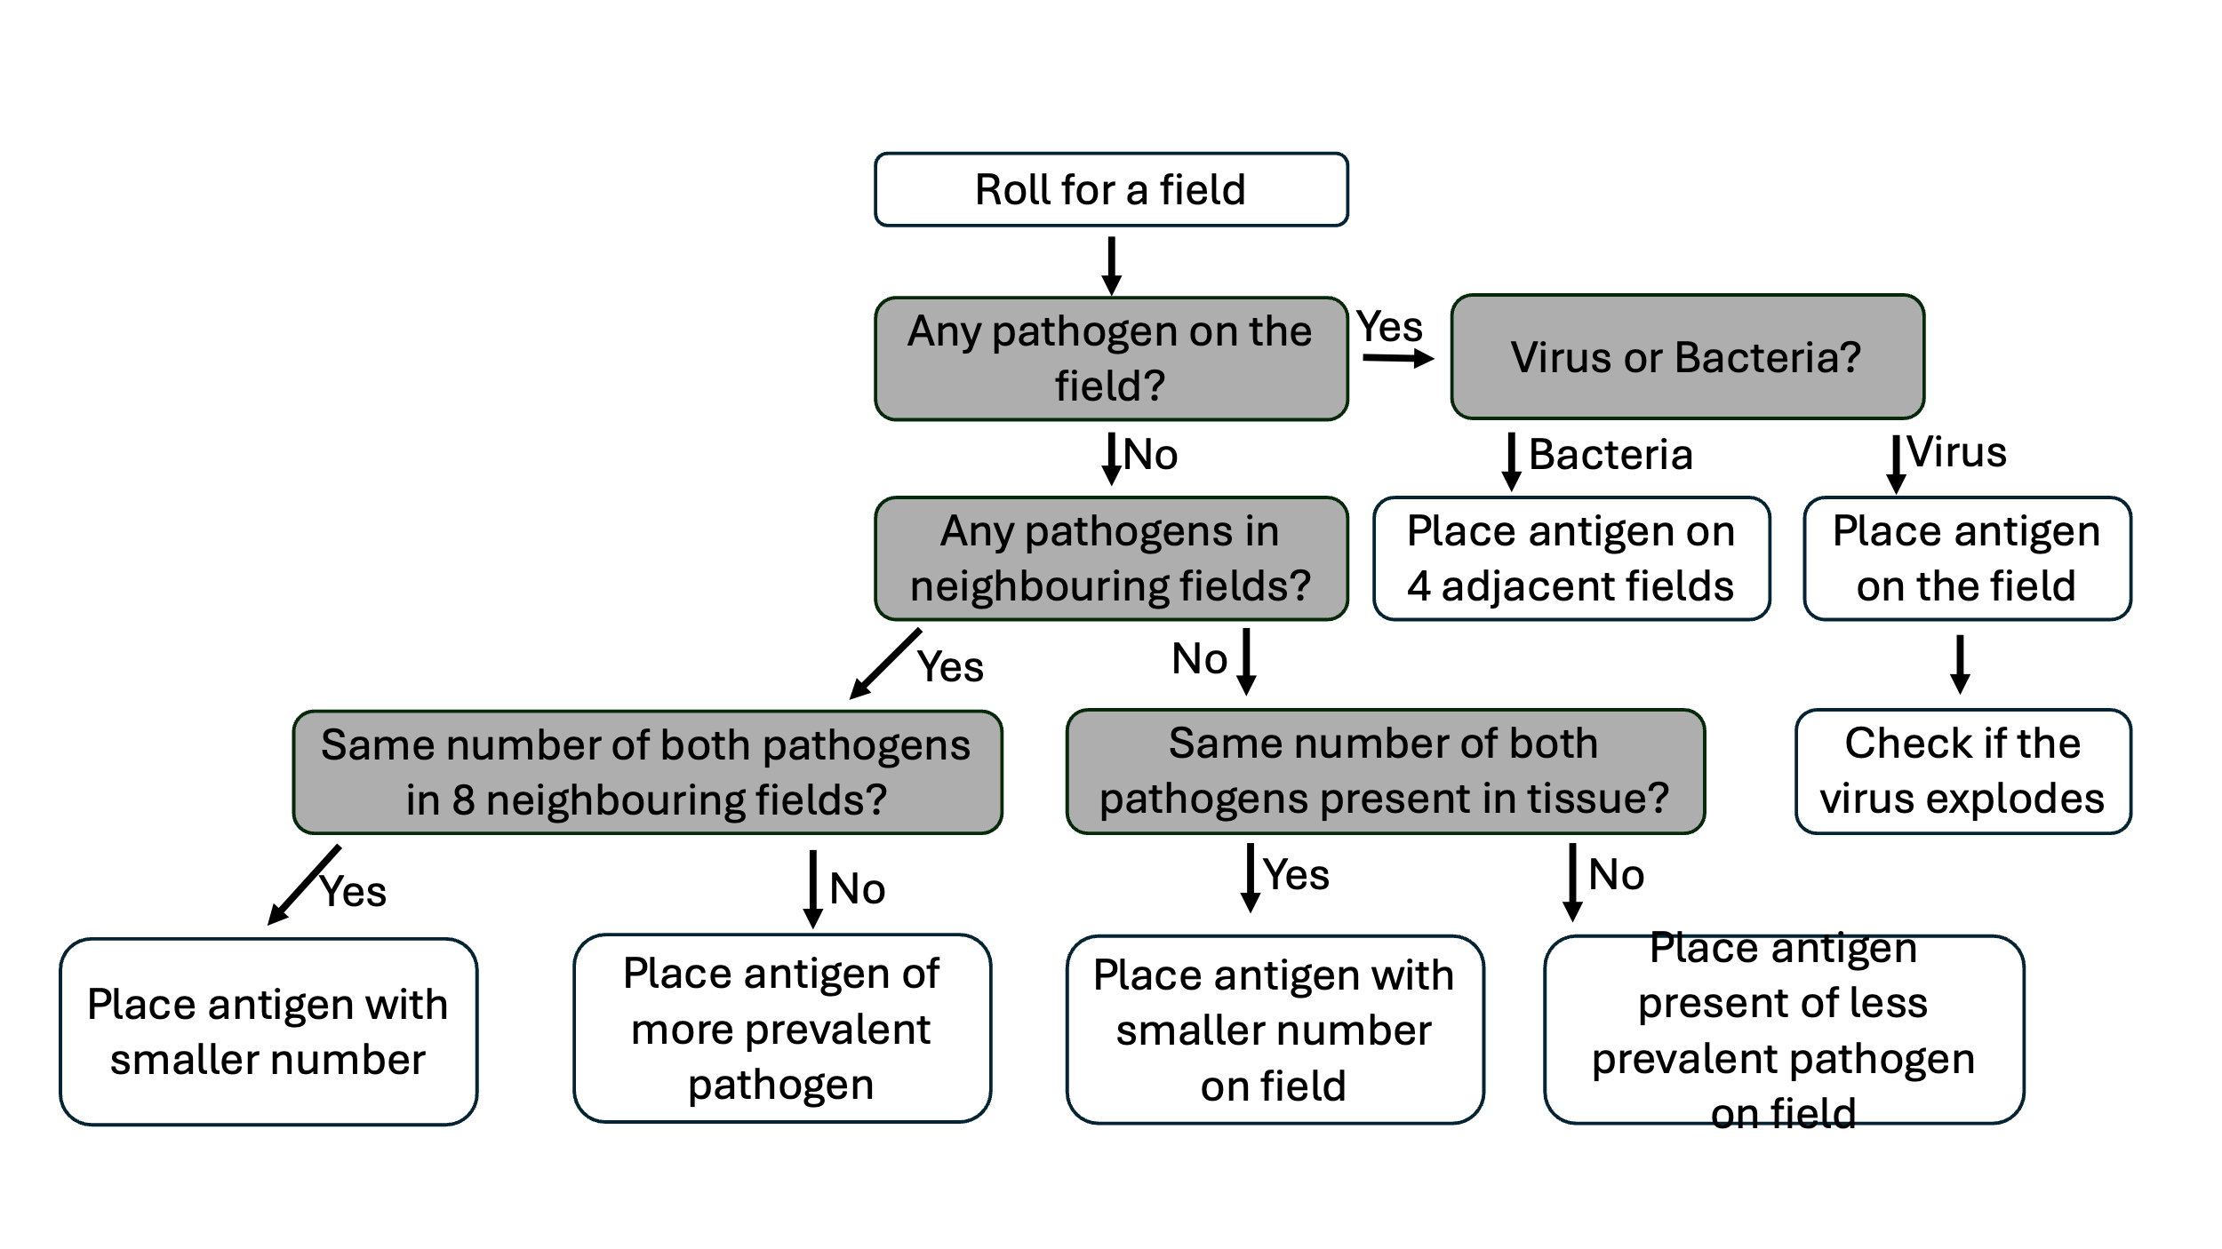
Switch cell | 2 ATP switch Immune Cell (exept neutrophile, which costs 0 ATP)
Movement | 1 ATP move a tile  2 ATP move onto a tile with pathogen  2 ATP move through lymphoid system
Makrophage  --always active-- | 2 ATP eat cell/ Bakterium  3 ATP eat immune complex  1 ATP pass along antigens  1 ATP digest and regenerate
Dendritic cell  --always active-- | 1 ATP take antigen probe from other player  3 ATP activate T-Cell  Only 1 ATP to move through lymphoid system
Neutrophile  --always active-- | 1 ATP neutralize pathogen  Switching to this cell card cost 0 ATP
T-Cell  antigen specific activation!! | 1 ATP Kill signal  2 ATP Kill series  1 ATP activate B-Cell  1 ATP switch antigen
B-Cell  antigen specific activation!! | 3 ATP secrete Antibodies (to form immune complex)  1 ATP switch antigen

